PROGRAM 2

CSC 1300 / Spring 2023



# IMPORTANT DATES

**Assignment Date**: Wednesday, February 15, 2023

**Due Date:** Wednesday, March 8, 2023

# Submission

Name your source file **username_prog2.cpp** and zip it in a folder and upload it to Program 2 in Assignments in ilearn.

(Replace **username** with your TNTECH username). Example: mine is named acrockett_prog2.cp.

# DESCRIPTION

You want to create a program that can predict a user’s future. All the user must do is answer a few questions and your program generates the following information about the user:

* Who they will marry
* How many children they will have
* Their job title
* Their business or organization
* Their salary
* The car they drive
* What kind of dwelling they will live in
* Their city and state they will live in

# Concepts

* menu-based programs
* use switch statements
* validating user input with loops
* allowing a program to run multiple times until user wants to quit
* organizing code in functions
* reading input from files

# INPUT

1. Three integer numbers between 1 and 100
2. Three job titles (2 they like & one they don’t like)
3. Three companies, restaurants, or organizations (2 they like & one they don’t like)
4. Three integer numbers between 10000 and 500000

# RANDOM NUMBERS

* Create a function that will generate a random number within a given range. The function will accept two integers to represent the low & high range and will return the random number. This function definition should be below the main function.
* Call this function whenever you are determining which of the three options to print for the user in output (generate between 1 & 3 inclusively).
* Call this function right before the for loops to determine iterations of the for loops when reading from the file (generate between 1 & 15 inclusively).

# Text Files

You are going to be reading some data from text files.

One text file with 15 types of dwellings (DWELLINGS.txt) is provided for you (see screen capture below). I uploaded two versions of this file. Use the one designed for your computer. If you have a Mac, use DWELLINGS_Mac.txt and if you have a Windows PC, use DWELLINGS_PC.txt.

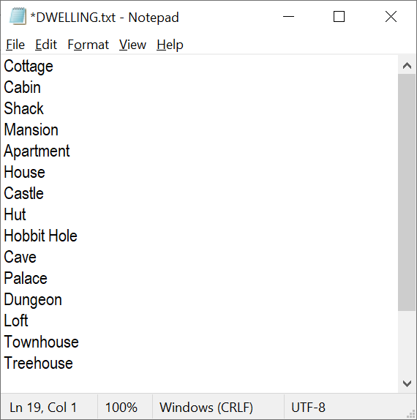

You must create **three** text (.txt) files (not provided for you) that have **15 lines of data** in them: **CARS.txt**, **LOCATIONS.txt**, and **PEOPLE.txt**. These text files must be included with your submission.

For each of the four pieces of information you are getting from the four different text files, you will create a for loop that will iterate the same number of times as the random number generated. Inside this for loop, you will have a getline statement that will read from the text file into the appropriate variable. You will have to open the specific file before the for loop, and close it after the for loop.

For example, if the random number generated between 1 and 15 was **7**, then the resulting output for “dwelling” should be **Castle**.

# other SPECIFICATIONS

* Indent and comment your code following good programming practice as discussed in class and shown in example programs.
* Your main function should call a function called **displayMenuGetChoice()**. This function doesn’t have any parameters but will return an integer indicating the user’s choice (1 or 2). This function will ask the user to either   
  1) Predict my future!   
  2) End the program.
  + Read in the user’s choice.
  + Validate the user’s choice with a while loop
  + Return the user’s choice back to the main function.

Remember to place the programmer-defined function BELOW the main function!

* You must have a **switch statement** to figure out which choice the user selected.
* The program should run over and over until the user selects to end the program using a **do-while loop.**
* You MUST validate user input with **while loops** if the input is a number to ensure the number is in the specified range. You may assume the user will enter in a number (not a character or string), but you can’t assume they enter a number within the specified range. Refer to sample output of how user input validation should behave. Be specific to the user to indicate which number was invalid.
* You MUST allow spaces to be included in all string input.

# OUTPUT

* The user’s spouse (data comes from file and is picked via a random number)
* The user’s type of house / dwelling (data comes from file and is picked via a random number)
* The location where the user will live (data comes from file and is picked via a random number)
* The car the user will drive (data comes from file and is picked via a random number)
* The number of children the user will have (based on input from user & random number generated between 1 & 3)
* Where the user will work, their job title, and their salary (based on input from user & random number generated between 1 & 3)

# SAMPLE OUTPUT

User input is highlighted in **yellow**.

Pick from the following menu:

1. Let's play MASH!

2. End program.

CHOOSE 1 or 2: 8

Invalid choice. CHOOSE 1 or 2: 1

You chose to predict your future!

First, I need just a little information.

Enter three numbers between 1 and 100, separated by a space.

-4 88 243

Invalid choice for the first number you entered.

Enter a number between 1 and 100.

7

Invalid choice for the third number you entered.

Enter a number between 1 and 100.

33

Enter in an awesome job title: Computer Scientist

Enter in another awesome job title: Data Scientist

Enter in the worst job title ever: Toilet Cleaner

Enter a company, organization, or restaurant you like: Amazon

Enter another company, organization, or restaurant you like: Google

Enter a company, organization, or restaurant you hate: Long John Silvers

Enter three numbers between 10,000 and 500,000, separated by a space.

13000

745843

250000

The second number you entered was invalid.

Enter a number between 10000 and 500000.

32194

****** YOUR FUTURE ******

You and your spouse, Kim Ung-Yong will live in a Treehouse in Kanrin-26 Inuyama, Aichi 484-0081, Japan and drive a Maroon 2010 Nissan Cube.

You and your spouse will have 33 children.

You will work at Amazon as a Computer Scientist making $13000 a year.

Pick from the following menu:

1. Let's play MASH!

2. End program.

CHOOSE 1 or 2: 1

You chose to predict your future!

First, I need just a little information.

Enter three numbers between 1 and 100, separated by a space.

8 58 22

Enter in an awesome job title: Dance Instructor

Enter in another awesome job title: Artist

Enter in the worst job title ever: English Teacher

Enter a company, organization, or restaurant you like: Cane Creek Rec Center

Enter another company, organization, or restaurant you like: Tennessee Tech University

Enter a company, organization, or restaurant you hate: McDonalds

Enter three numbers between 10,000 and 500,000, separated by a space.

85384 393999 13933

****** YOUR FUTURE ******

You and your spouse, Adele will live in a House in 13 Rue Darnel, 62100 Calais, France and drive a Maroon 2010 Nissan Cube.

You and your spouse will have 22 children.

You will work at McDonalds as a English Teacher making $393999 a year.

Pick from the following menu:

1. Let's play MASH!

2. End program.

CHOOSE 1 or 2: 2

You chose to end the program.

Bye!

## Sample Text Files

Please make your own. These are just examples.

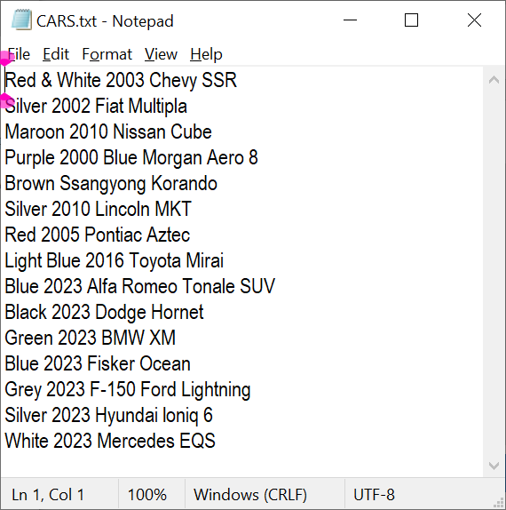 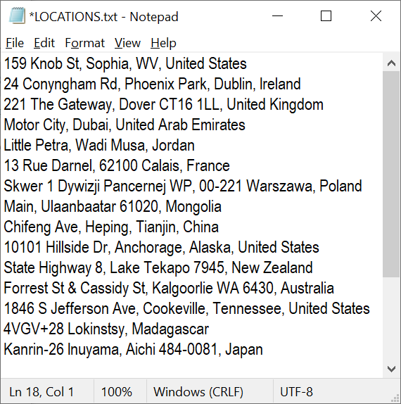

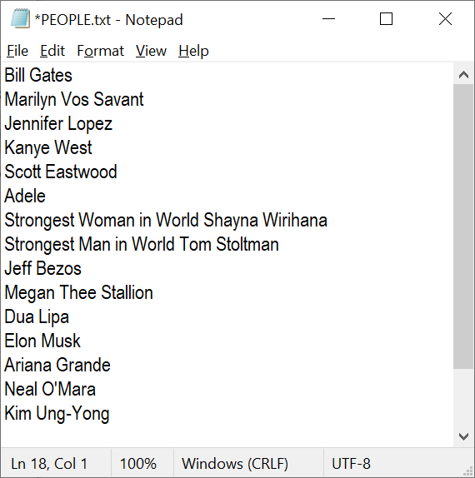

# GRADING

Refer to the grading rubric in the Program 2 assignment in ilearn to see how you will be graded on this assignment.